**PRACTICE1: ACCESS XML FILE WITH DOM**

OBJECTIVE: HAVING THE FILE BOOKS.XML, CREATE THE DOM TREE.

**The file Books.xml has the content:**

<?xml version="1.0" encoding="UTF-8"?>

<Books xmlns:xsi="http://www.w3.org/2001/XMLSchema-instance" xsi:noNamespaceSchemaLocation="Books.xsd">

<Book published="1894">

<Title>The Jungle Book</Title>

<Author>Rudiard Kipling</Author>

</Book>

<Book published="2003">

<Title>The Da Vinci Code</Title>

<Author>Dan Brown</Author>

</Book>

<Book published="1981">

<Title>The name of the Rose</Title>

<Author>Umberto Eco</Author>

</Book>

<Book published="1605">

<Title>Don Quixote</Title>

<Author>Cervantes</Author>

</Book>

</Books>

PRACTICE:

1. Create the class AccessXMLDOM
2. Create the method openXMLtoDOM (File f):

We’ll use the following classes:

* Document doc;//import org.w3c.dom.Document;
* DocumentBuilderFactory factory;// import javax.xml.parsers.DocumentBuilderFactory;
* DocumentBuilder: its method parse() creates the DOM model.

Our code will be inside a try/catch block

**try**{

//code

}**catch**(Exception e){

System.***out***.println(e);

}

The code will be:

**import** javax.xml.parsers.DocumentBuilder;

**import** javax.xml.parsers.DocumentBuilderFactory;

**import** org.w3c.dom.*;//for Document

**import** org.w3c.dom.Document;

**import** org.w3c.dom.*;//for Document

**import** java.util.*;

**import** java.io.*;//class File

**public** **class** AccesXMLDOM {

Document doc;

**public** **int** openXMLtoDOM (File f){

**try**{

System.***out***.println("Opening XML file and creating DOM ....");

//new object DocumentBuilder

DocumentBuilderFactory factory = DocumentBuilderFactory.*newInstance*();

//ignore comments and white spaces

factory.setIgnoringComments(**true**);

factory.setIgnoringElementContentWhitespace(**true**);

//DocumentBuilder will have the DOM loaded when we parse the xml file

DocumentBuilder builder=factory.newDocumentBuilder();

doc=builder.parse(f);

//now doc points to the DOM tree and we can traverse it.

System.***out***.println("DOM created succesfully.");

**return** 0;//if the method works

}**catch**(Exception e){

System.***out***.println(e);

**return** -1;//if the method fails

}

}

}

1. Try the code, with a new class (first, you need to have the xml file Books.xml in the right path ( inside the parent project of the src folder in this case)

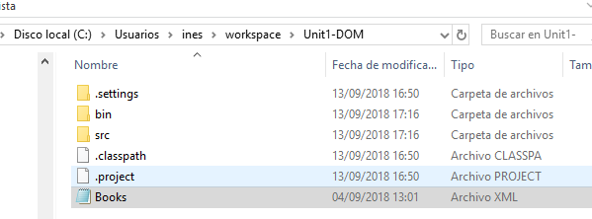

**import** java.io.File;

**public** **class** UseXMLDOM {

**public** **static** **void** main(String[] args) {

AccesXMLDOM a=**new** AccesXMLDOM();

File f=**new** File("Books.xml");//we must have Books.xml in the right path

a.openXMLtoDOM(f);

}

}

We will see:

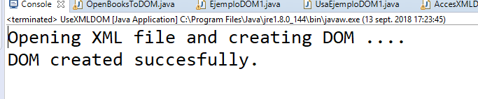

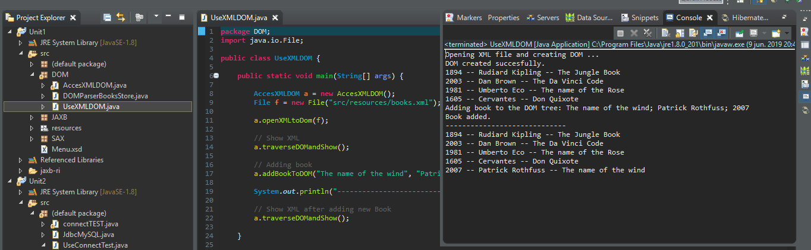

1. After this, we will write the code to traverse and show the nodes of the DOM tree in PRACTISE 2